TopShooter

Design Documentation

Yaacov Simmons, Stefan Ganescu, Iain Forrester, Aiden Deegan, Ross Laing

Contents

Planning Stage 2

Project Brief 2

Physical Resources 2

Information Resources 2

Game Comparison 2

Physical Design Aesthetic: 3

Gameplay: 3

Use Case Diagrams 3

References: 4

# Planning Stage

## Project Brief

For the purposes of completing the group coursework of the Web Development Subject, our group known as TopShooter will be completing a web-based Mass Multiplayer Online Game (MMOG). The game will be a top down shooter which will feature the last person standing game type, in which a group of five to six players will fight it out to win the game with only one winner.

The game will have unique individual accounts which can be created by the users so that they can participate in the game. These unique accounts will then be held on a secure database. Having an account will allow the user's score to be tracked on our scoreboard. The users will also be able to log in and out of their account and will be able to edit their details.

As for the game itself, all players will be placed into a game map and spaced sensibly at the start, so as to avoid players being defeated instantly. Each character controlled by the players will have a weapon that is to be used to defeat the other players within the game. To have that multiplayer experience, a designated server will pass data to and from a player's device. This data will allow a user to show its movements and actions to other players, and vice versa.

The game will have one static map that will be used for each game, these maps may vary. Each of the maps will feature various objects that players use as cover. Neither bullets nor players can go through the objects placed on the map, this will allow for more varied gameplay and allow for better challenge for players.

Scoring will also be featured in games, with points being allocated to killing an enemy player and for winning the game. These scores will be tracked on the leaderboard, providing they have an account, as previously mentioned.

All players will have the ability to send in bug reports if they notice any issues that arise while playing the game, this error report will be sent directly to the TopShooter team so that the issues can be resolved. Players will also have access to a help/support feature which will act as a game manual for the game, this will allow all players to get the best experience out of the game.

## Physical Resources

## Information Resources

## Game Comparison

For team TopShooter we have opted to design a top down last man standing shooter game that will focus on players (5 per match) battling against each other until there is only one player left, this is further detailed in the brief provided by the group. In researching a functional game, the team decided to also research games that share similar design aspects so as to draw inspiration and help in the overall build of the project. The following will contain a list of games and the features that they each have that will be used in a similar fashion in TopShooter.

### Physical Design Aesthetic:

#### Hotline Miami:

In Hotline Miami the gameplay is somewhat simplistic in the manner that the player navigates a building in a top-down perspective. The goal of the game is to clear all opponents from each floor as quickly as possible.

The way in which TopShooter will draw from this game is that of the physical looks and initial gameplay design. TopShooter will feature a much cleaner, less cluttered and simplistic design while featuring similar gameplay in that the players will need to clear all the other players from the stage before they can be declared the winner. Hotline Miami also plays with corridors and rooms in which enemies may have advantages of cover, the TopShooter team also hope to implement a similar functionality to the finished product so as to make the game more competitive.

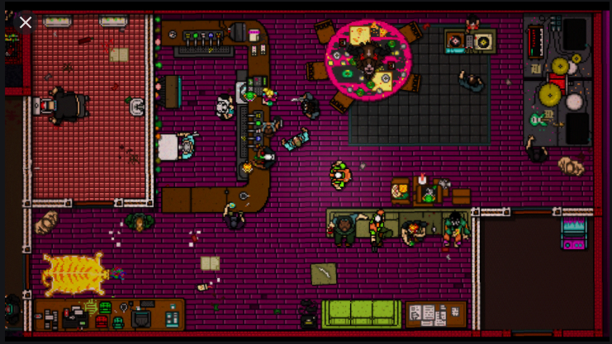

### Gameplay:

#### PlayerUnknown Battlegrounds/Fortnite/Other Battle Royale:

Battle Royale games such as PUBG and Fortnite have increased in popularity in recent years and the TopShooter team have opted to draw on the competitive aspect that these games have been centred on. The idea that there can be only one winner works well with a simplistic design that our game is aiming for. Rather than using respawn and a points system like many other top down shooter games (such as Hotline Miami) we will opt for the simple method of when a player is killed they are eliminated from the match and will need to wait for the next match after the winner is eventually decided between the 5 in game players.

## Use Case Diagrams

# Design

## Identify Suitable Colour Schemes

## Sprite Design Examples

## Game Map Design Examples

## Menu Wireframe

## Game Wireframe

## Normalisation

## Database ERD

# References:

<https://www.google.com/search?q=hotline+miami&rlz=1C1CHBF_en-GBGB813GB813&sxsrf=ALeKk00GfitQdOjMM3j1ZxLQMVGxBg8SSg:1601385095340&source=lnms&tbm=isch&sa=X&ved=2ahUKEwjR-4WuuI7sAhVkShUIHYGrCrwQ_AUoAXoECCIQAw&biw=1536&bih=722#imgrc=hoEZddOPONJ1qM>